Assignment: Data Formats

Scott Freedman

Ira A. Fulton Schools of Engineering, Arizona State University

IFT 458: Middleware Programming & Database Security

Professor Dinesh Sthapit

February 12, 2023

**Reusable components to create a composite components**

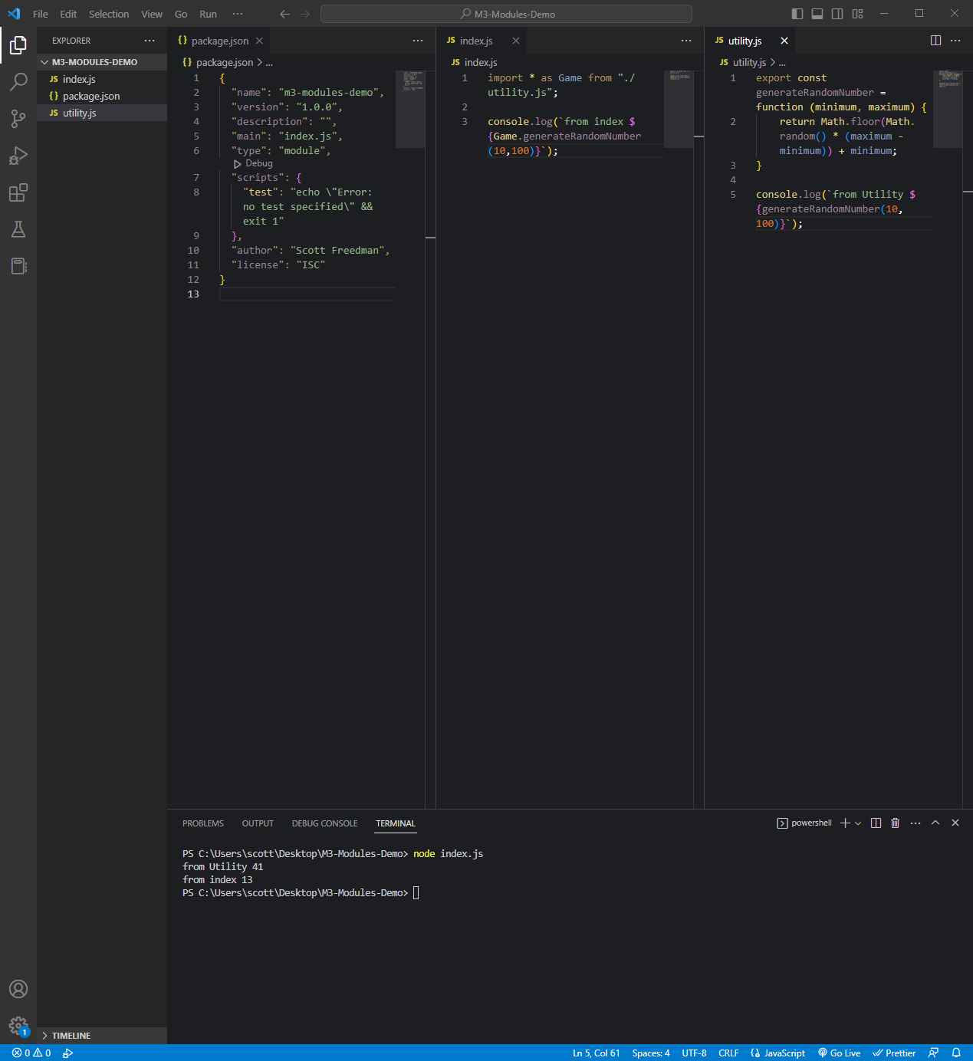

*Package.json code:*

{

  "name": "m3-modules-demo",

  "version": "1.0.0",

  "description": "",

  "main": "index.js",

  "type": "module",

  "scripts": {

    "test": "echo \"Error: no test specified\" && exit 1"

  },

  "author": "Scott Freedman",

  "license": "ISC"

}

*Index.js code:*

import * as Game from "./utility.js";

console.log(`from index ${Game.generateRandomNumber(10,100)}`);

*utility.js code:*

export const generateRandomNumber = function (minimum, maximum) {

    return Math.floor(Math.random() * (maximum - minimum)) + minimum;

}

console.log(`from Utility ${generateRandomNumber(10,100)}`);

**Using Importing External Modules (third-party modules)**

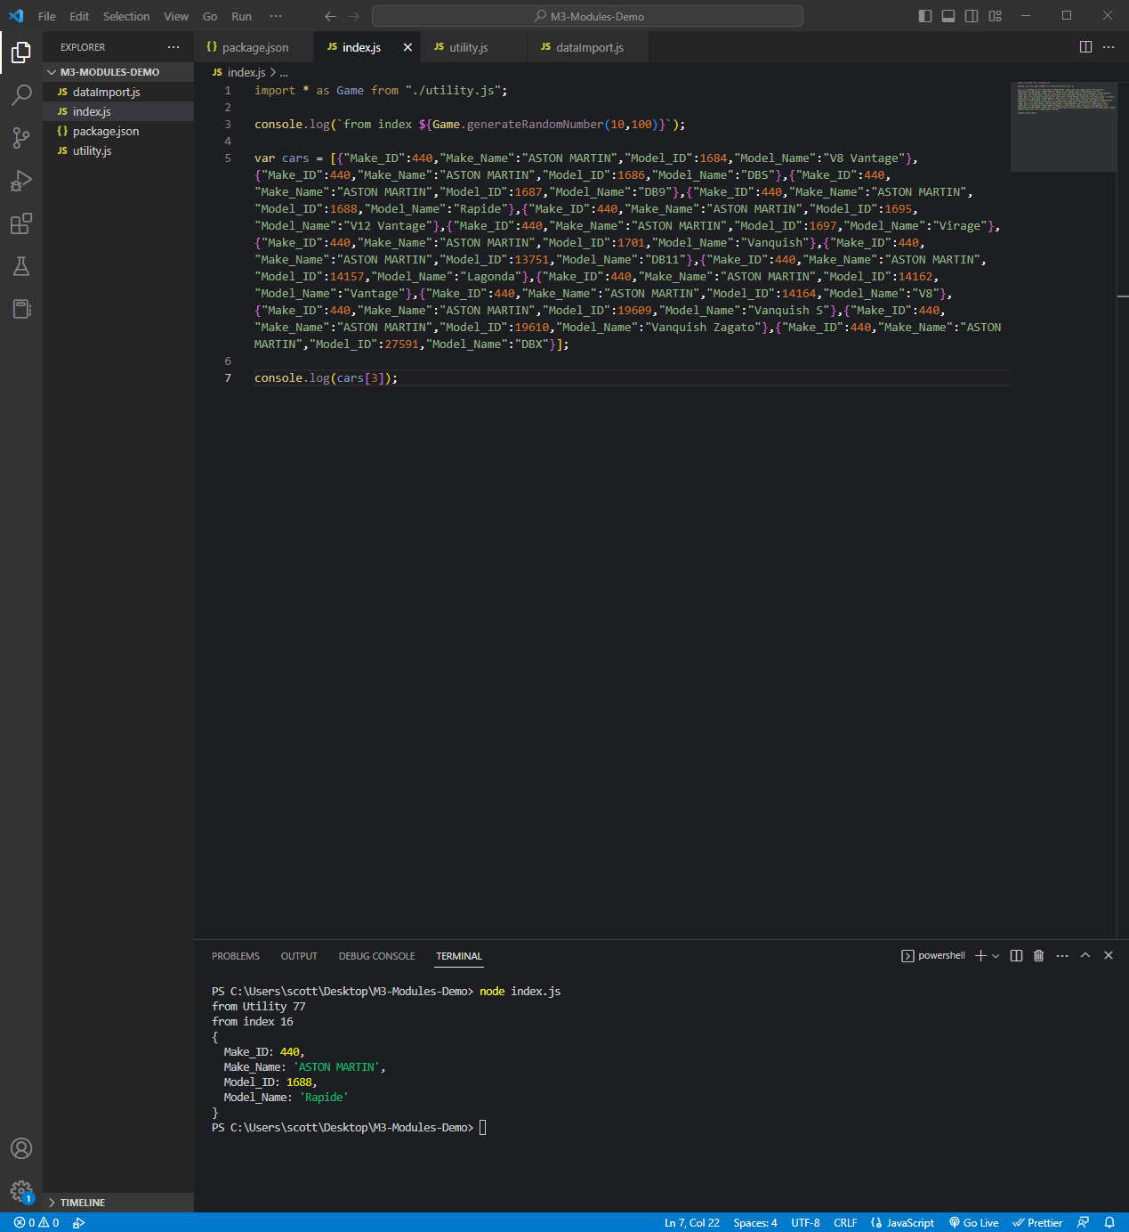

*Code:*

import * as Game from "./utility.js";

console.log(`from index ${Game.generateRandomNumber(10,100)}`);

var cars = [{"Make_ID":440,"Make_Name":"ASTON MARTIN","Model_ID":1684,"Model_Name":"V8 Vantage"},{"Make_ID":440,"Make_Name":"ASTON MARTIN","Model_ID":1686,"Model_Name":"DBS"},{"Make_ID":440,"Make_Name":"ASTON MARTIN","Model_ID":1687,"Model_Name":"DB9"},{"Make_ID":440,"Make_Name":"ASTON MARTIN","Model_ID":1688,"Model_Name":"Rapide"},{"Make_ID":440,"Make_Name":"ASTON MARTIN","Model_ID":1695,"Model_Name":"V12 Vantage"},{"Make_ID":440,"Make_Name":"ASTON MARTIN","Model_ID":1697,"Model_Name":"Virage"},{"Make_ID":440,"Make_Name":"ASTON MARTIN","Model_ID":1701,"Model_Name":"Vanquish"},{"Make_ID":440,"Make_Name":"ASTON MARTIN","Model_ID":13751,"Model_Name":"DB11"},{"Make_ID":440,"Make_Name":"ASTON MARTIN","Model_ID":14157,"Model_Name":"Lagonda"},{"Make_ID":440,"Make_Name":"ASTON MARTIN","Model_ID":14162,"Model_Name":"Vantage"},{"Make_ID":440,"Make_Name":"ASTON MARTIN","Model_ID":14164,"Model_Name":"V8"},{"Make_ID":440,"Make_Name":"ASTON MARTIN","Model_ID":19609,"Model_Name":"Vanquish S"},{"Make_ID":440,"Make_Name":"ASTON MARTIN","Model_ID":19610,"Model_Name":"Vanquish Zagato"},{"Make_ID":440,"Make_Name":"ASTON MARTIN","Model_ID":27591,"Model_Name":"DBX"}];

console.log(cars[3]);

**Data Formats and Data Exchange**

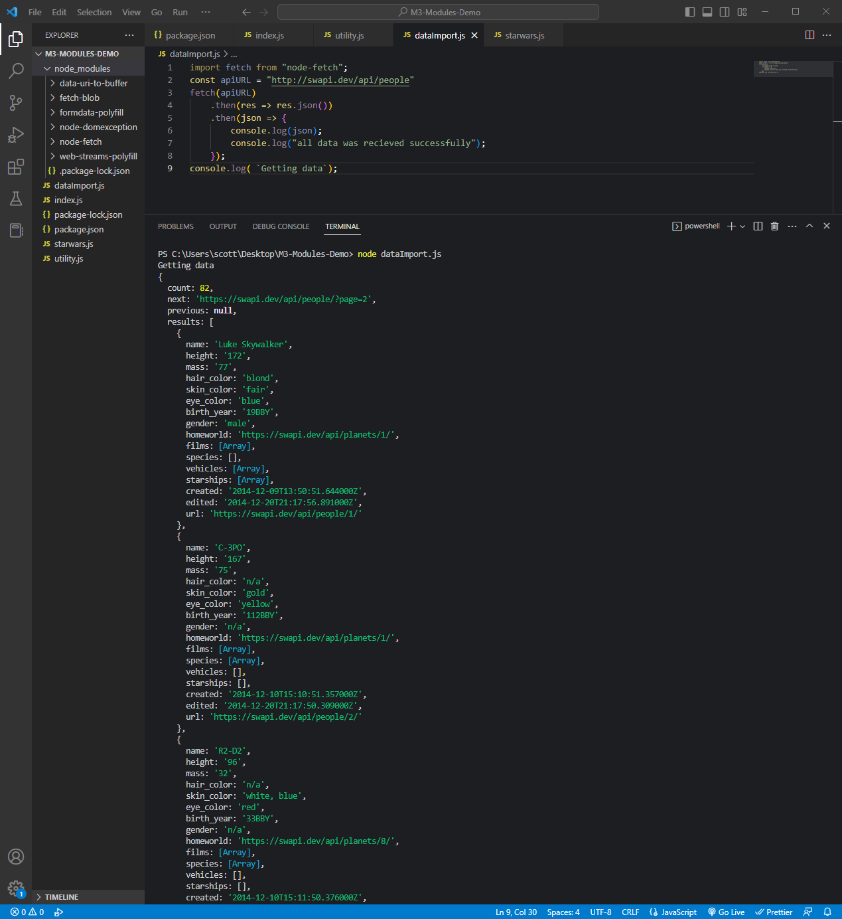

*Code:*

import fetch from "node-fetch";

const apiURL = "http://swapi.dev/api/people"

fetch(apiURL)

    .then(res => res.json())

    .then(json => {

        console.log(json);

        console.log("all data was recieved successfully");

    });

console.log( `Getting data`);

**Content Negotiation**

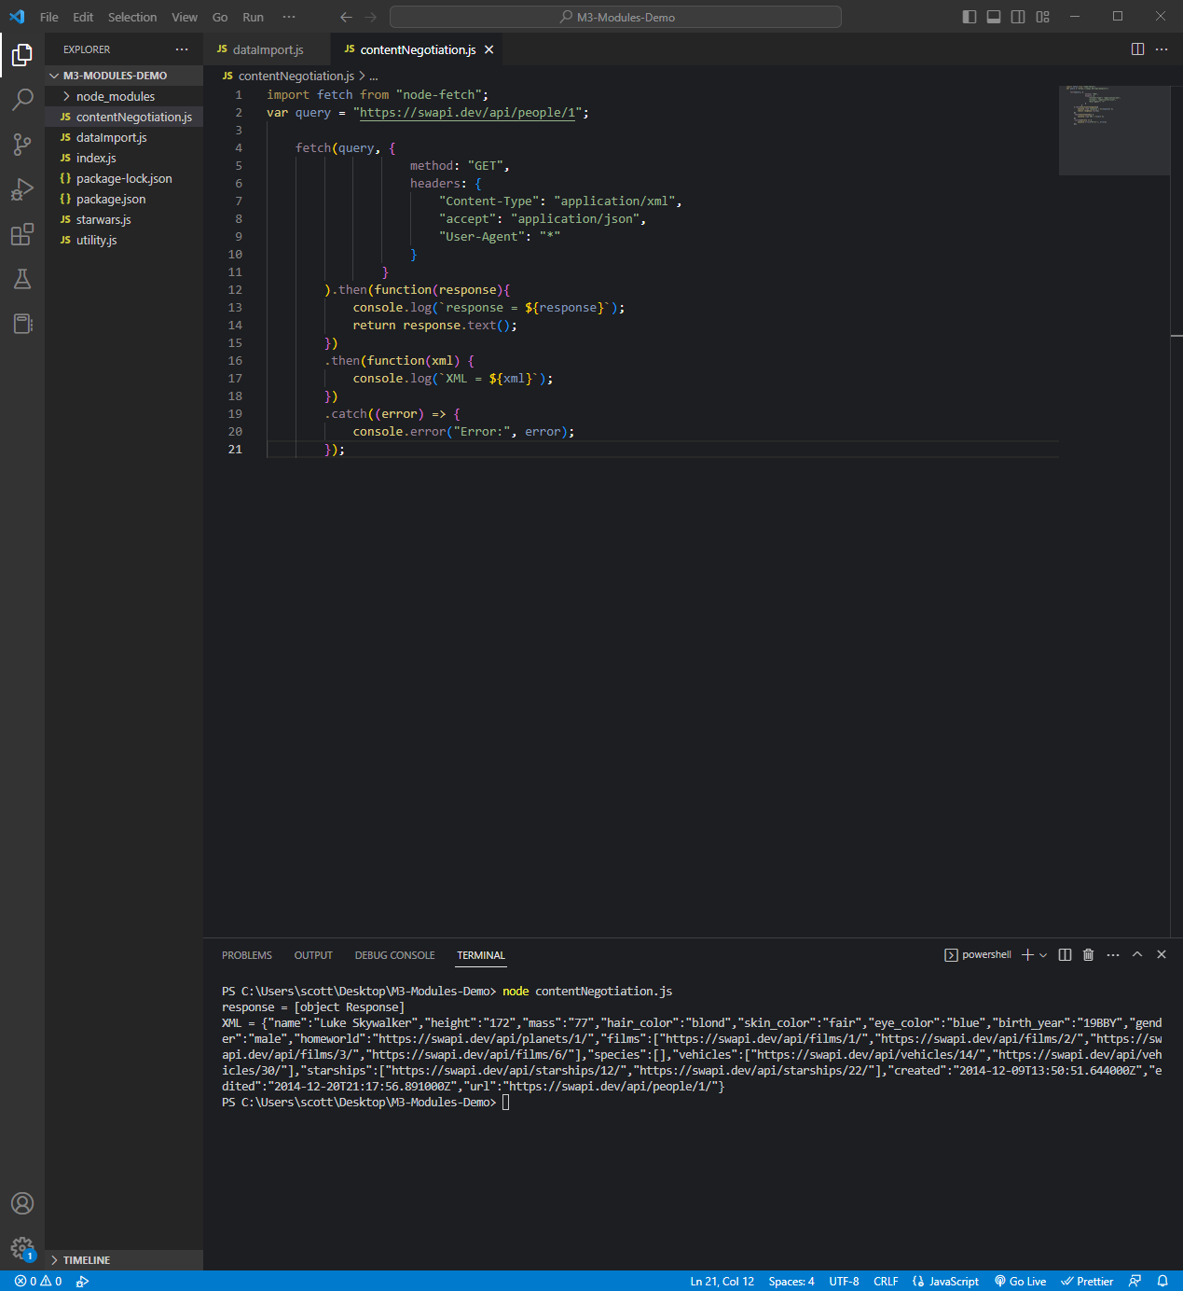

*Code:*

import fetch from "node-fetch";

var query = "https://swapi.dev/api/people/1";

    fetch(query, {

                    method: "GET",

                    headers: {

                        "Content-Type": "application/xml",

                        "accept": "application/json",

                        "User-Agent": "*"

                    }

                }

        ).then(function(response){

            console.log(`response = ${response}`);

            return response.text();

        })

        .then(function(xml) {

            console.log(`XML = ${xml}`);

        })

        .catch((error) => {

            console.error("Error:", error);

        });